S42B-Encoded-Stepper-Motor Manual

References:

<https://github.com/bigtreetech/BIGTREETECH-S42B-V1.0>

### **What’s in the box:**

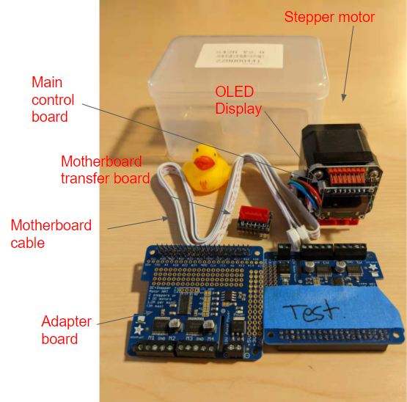

Figure 1: Overview of the S42B Encoded Stepper Motor Package

You can simply use the Stepper motor with an OLED display and the motherboard cable. The encoded stepper motor has its own control board already. The layout of the control board is as shown in Figure 2.

Using the OLED display, you can use the button on the right side of the display to adjust the values such as direction, number of steps per cycle, current value, etc.

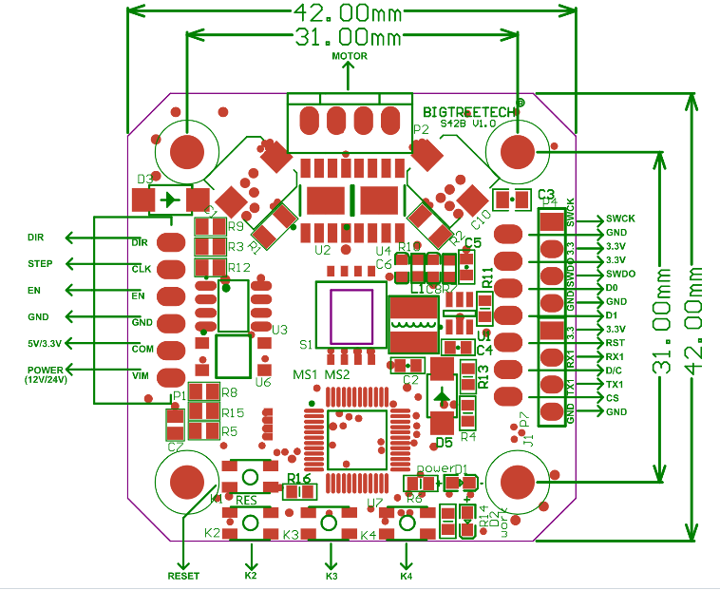

Figure 2: Control board pinout

Focusing the pin on the left in figure 2, you need a power of 12V/24V to the first pin, and 5V/3.3V to the second pin. All the power supplies need to be grounded together with the GND. If you are controlling the stepper motor with a Raspberry Pi, you need to connect the GND from the control board to the GND pin on the Pi.

### **How to enable the closed-loop function:**

For an encoded stepper motor, it is good to enable the closed-loop function, which is an automatic control system in which an operation, process, or mechanism is regulated by feedback.

To enable the close-loop on the S42B stepper motor, you need to switch on the **DIP 2**. (Took off the OLED, and you’ll see the DIP switches in the center area of the control board, as shown in Figure3.)

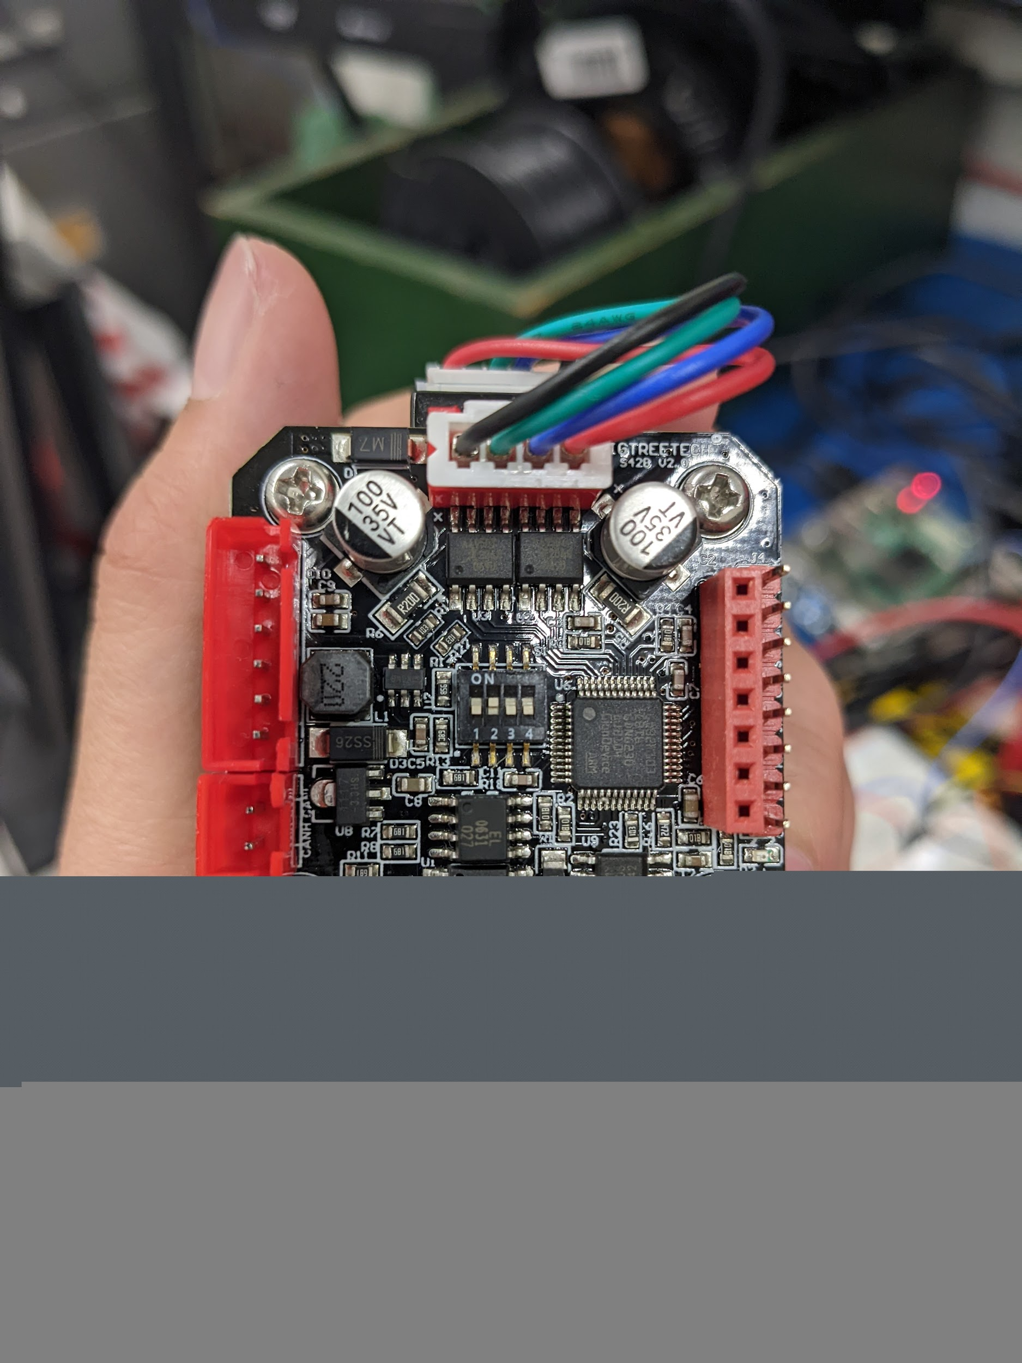

Figure 3: DIP switches on the control board. DIP2 is the key to enable closed-loop control.

To check that the closed-loop is functioning, power on the stepper motor and choose the current using the OLED display to be around 1600mA. Low current would not hold the shaft tight enough.

More details can be found in the Phys150 weekly slides.